**VIVEKANAND EDUCATION SOCIETY’S**

**INSTITUTE OF TECHNOLOGY**

**Department of Computer Engineering**



Project Report on

# Portfolio Optimization and Risk Management Using Advanced Quantitative Models

In partial fulfillment of the Fourth Year (Semester–VII), Bachelor of Engineering

(B.E.) Degree in Computer Engineering at the University of Mumbai Academic Year 2024-2025

**Project Mentor**

Prof. Mrs. Abha Tewari

**Submitted by**

KRISHNAM RAJA D17A-49

UZAIR SHAIKH D17A-56

DHIREN SIDHWANI D17A-60

(2024-25)

## VIVEKANAND EDUCATION SOCIETY’S INSTITUTE OF TECHNOLOGY

**Department of Computer Engineering**



**CERTIFICATE of Approval**

This is to certify that ***Krishnam Raja (49), Uzair Shaikh (56), Dhiren Sidhwani (60)*** of Fourth Year Computer Engineering studying under the University of Mumbai has satisfactorily presented the project on “***Portfolio Optimization and Risk Management Using Advanced Quantitative Models***” as a part of the coursework of PROJECT-I for Semester-VII under the guidance of  ***Prof. Mrs. Abha Tewari*** in the year 2024-2025.

______***_______________***

Date

| __________________ |  | __________________ |
| --- | --- | --- |
| Internal Examiner |  | External Examiner |

_________________ __________________ __________________

Project Mentor Head of the Department Principal

Dr. Mrs. Nupur Giri Dr. J. M. Nair

## ACKNOWLEDGEMENT

We are thankful to our college Vivekanand Education Society’s Institute of Technology for considering our project and extending help at all stages needed during our work of collecting information regarding the project.

It gives us immense pleasure to express our deep and sincere gratitude to Assistant Professor  **Prof. Mrs. Abha Tewari** (Project Guide) for her kind help and valuable advice during the development of project synopsis and for her guidance and suggestions.

We are deeply indebted to Head of the Computer Department **Dr.(Mrs.) Nupur Giri** and our Principal **Dr. (Mrs.) J.M. Nair ,** for giving us this valuable opportunity to do this project.

We express our hearty thanks to them for their assistance without which it would have been difficult in finishing this project synopsis and project review successfully.

We convey our deep sense of gratitude to all teaching and non-teaching staff for their constant encouragement, support and selfless help throughout the project work. It is great pleasure to acknowledge the help and suggestion, which we received from the Department of Computer Engineering.

We wish to express our profound thanks to all those who helped us in gathering information about the project. Our families too have provided moral support and encouragement several times.

### Computer Engineering Department

**COURSE OUTCOMES FOR B.E PROJECT**

Learners will be to:-

| **Course Outcome** | **Description of the Course Outcome** |
| --- | --- |
| CO1 | Do literature survey/industrial visit and identify the problem of the selected project topic. |
| CO2 | Apply basic engineering fundamental in the domain of practical applications FORproblem identification, formulation and solution |
| CO3 | Attempt & Design a problem solution in a right approach to complex problems |
| CO4 | Cultivate the habit of working in a team |
| CO5 | Correlate the theoretical and experimental/simulations results and draw the proper inferences |
| CO6 | Demonstrate the knowledge, skills and attitudes of a professional engineer & Prepare report as per the standard guidelines. |

**ABSTRACT of the project**

In today’s complex financial markets, portfolio optimization and risk management have become paramount for investors aiming to balance returns and minimize risks. This project leverages advanced quantitative models, including LSTM (Long Short-Term Memory) and MPT to enhance portfolio management. These models not only factor in historical market data but also predict future price movements and potential risks, allowing for more adaptive and informed asset allocation decisions.

The use of LSTM networks, known for their ability to capture long-term dependencies in time-series data, provides a more nuanced analysis of asset trends and market fluctuation. Together, these models allow for dynamic portfolio adjustments, which are key in managing both volatility and market unpredictability.

**Index**

**Index**

**Chapter 1 : Introduction**

1.1. Introduction to the project

1.2. Motivation for the project

1.3. Drawback of the existing system (if any)

1.4. Problem Definition

1.5 Relevance of the Project

1.6 Methodology used

**Chapter 2: Literature Survey**

2.1 Research papers referred

2.2 Limitation Existing system or Research gap

**Chapter 3: Requirements for the proposed system**

3.1 Functional Requirements

3.2. Non-Functional Requirements

3.3. Constraints

3.4. Hardware & Software Requirements

3.5. Techniques utilized till date for the proposed system

3.6. Tools utilized till date for the proposed system

3.7. Algorithms utilized in the existing systems

3.8. Your project Proposal (after analyzing the Requirements)

**Chapter** **4: Proposed Design**

4.1. Block diagram representation of the proposed system

4.2. Modular diagram representation of the proposed system

4.3 Implementation

4.4. Project Scheduling & Gnatt Chart

**5. Proposed Results and Discussions**

**6. Plan of action for the next semester**

a. Work done till date (4 -5 Lines)

b. Plan of action for project II

**7. Conclusions**

**8. References**

**9. Appendix**

**10. Draft of Research Paper**

### 

### 

### 

### 

### 

### Chapter 1 : Introduction

**1.1. Introduction to the project**

The financial markets are governed by a complex network of assets, each subject to various economic forces. In this environment, portfolio optimization plays a critical role in achieving a balance between risk and return. There are two primary types of risk: systematic (market-wide) and unsystematic (asset-specific). Systematic risk, such as inflation or political instability, affects the entire market and is unavoidable. Unsystematic risk, on the other hand, is specific to individual assets and can be mitigated through proper diversification. To maximize portfolio returns while minimizing risk, investors often rely on quantitative models. Traditional portfolio management approaches use techniques like mean-variance optimization to allocate assets, but these often lack the predictive power necessary to handle the complexity of today’s markets.

This project introduces a robust model for portfolio optimization by integrating machine learning techniques like LSTM. LSTMs are highly effective in capturing both short-term and long-term market trends from historical data. This combination allows for more accurate forecasting of asset behaviors and portfolio returns. By analyzing vast datasets and identifying patterns, these models help in creating a dynamically optimized portfolio that adjusts to market volatility and price fluctuations.

The advanced techniques employed in this project significantly improve the precision and effectiveness of portfolio management. This approach not only addresses systematic risk through diversification but also mitigates unsystematic risk by allocating assets based on data-driven predictions. The result is a framework that maximizes returns while keeping risk exposure within acceptable limits. Investors benefit from a more reliable and adaptive strategy, ensuring better performance under varying market conditions.

Timely and accurate portfolio optimization is crucial for effective financial planning and better investment outcomes. However, traditional methods of portfolio management often require labor-intensive and costly analysis, leading to potential delays in decision-making. Our framework addresses this challenge by harnessing the principles of Modern Portfolio Theory (MPT), which emphasizes the importance of diversification and the risk-return trade-off. By analyzing historical data and correlations among various assets, MPT enables the creation of an optimized portfolio that balances risk and expected return. The portfolio optimization process involves four key stages: Data Preprocessing, Risk Assessment, Asset Allocation, and Performance Evaluation. By applying these methodologies, our framework aims to significantly improve the efficiency and accuracy of portfolio management.

Traditional methods, while valuable, now face challenges in keeping pace with the increasing complexity and volatility of financial markets. Recognizing this, the focus of this project is to enhance the precision and adaptability of portfolio optimization using Modern Portfolio Theory. This initiative seeks to improve financial returns and risk management, maximizing the potential for successful investment strategies in an evolving market landscape.

**1.2. Motivation for the project**

The motivation behind our portfolio optimization framework extends beyond merely automating investment strategies for financial organizations. It encompasses several critical aspects of effective financial management and risk mitigation.

Firstly, the excessive costs and inefficiencies associated with traditional portfolio management methods are significant challenges. By utilizing Modern Portfolio Theory, our framework aims to provide accurate asset allocation and risk assessment, reducing the financial burden on investors while maintaining high standards of investment performance.

Secondly, the increasing volatility and complexity of financial markets have become pressing concerns for investors. Factors such as geopolitical events, economic fluctuations, and market sentiment necessitate the development of advanced optimization tools. Our framework seeks to provide timely insights into potential risks and opportunities, promoting proactive investment strategies and better financial outcomes.

Thirdly, the current fragmentation of financial data can hinder effective portfolio analysis and decision-making. Our framework aims to create a structured and easily accessible digital repository of investment data, streamlining the investment process and enabling comprehensive analysis and strategic planning.

In summary, the motivation behind our portfolio optimization framework lies in cost reduction, efficient financial management, proactive investment strategies, and organized data management—all of which are vital to advancing investment practices and promoting a holistic approach to portfolio optimization.

**1.3. Drawback of the existing system**

Existing portfolio optimization and stock prediction systems, especially in the Indian market, suffer from several limitations:

1. **Limited Access to Advanced Tools**: Most portfolio management tools available to retail investors are limited in terms of functionality and analytical capabilities. They lack access to the sophisticated machine learning models and financial algorithms used by institutional investors, making it difficult for individual investors to make data-driven decisions.
2. **Manual Data Processing**: Traditional systems often require manual analysis and data processing, which is time-consuming and prone to human error. These systems do not leverage the power of automation and real-time data processing that modern machine learning techniques offer.
3. **Inadequate Risk Management**: Many existing platforms do not provide adequate tools for risk assessment and management, leaving investors without a clear understanding of the potential risks associated with their portfolios. There is also a lack of scenario-based analysis that can simulate market conditions and assess portfolio performance under different circumstances.
4. **Fragmented Data Sources**: Current systems often rely on static datasets and do not integrate real-time stock prices, news, and market trends, which are critical for making timely investment decisions. This creates a lag in the availability of actionable insights.
5. **One-size-fits-all Recommendations**: Many platforms provide generic stock recommendations, which are not tailored to individual preferences or risk tolerance. This results in suboptimal investment strategies for users with different financial goals.

**1.4. Problem Definition**

The financial sector faces significant challenges in efficiently and effectively managing investment portfolios. Traditional methods often rely on manual analysis and outdated strategies, leading to inefficiencies and higher costs for investors. Additionally, the increasing volatility of financial markets underscores the urgent need for proactive portfolio management strategies. The fragmentation of financial data further complicates effective analysis and decision-making. To address these issues, our portfolio optimization framework aims to develop a systematic approach that utilizes Modern Portfolio Theory to enhance investment performance and promote equitable access to advanced financial management.

**Objectives:**

1. **Develop a comprehensive portfolio optimization framework** that automates asset allocation and risk assessment using Modern Portfolio Theory, ensuring a data-driven approach to investment decisions.
2. **Optimize cost-efficiency** by minimizing reliance on traditional management practices, thereby reducing fees and promoting accessibility to effective portfolio management strategies.
3. **Enhance accuracy and responsiveness** in portfolio optimization, enabling investors to adapt to market changes and make informed decisions in a timely manner.
4. **Create a structured digital repository** for storing and analyzing investment data, improving the efficiency of portfolio management and facilitating comprehensive market research.
5. **Contribute to the advancement of financial technologies**, aiming to alleviate the burden of market volatility on investors and encourage a proactive approach to portfolio management

**1.5 Relevance of the Project**

The relevance of our portfolio optimization framework lies in its alignment with the evolving demands of today's financial landscape. As markets become increasingly volatile and interconnected, investors face heightened uncertainty regarding asset performance and risk exposure. Traditional methods often struggle to adapt to these rapid changes, resulting in missed opportunities and suboptimal returns. Our project leverages Modern Portfolio Theory to create a robust framework that allows investors to navigate complexities in the market more effectively. By providing a systematic approach to asset allocation and risk management, we aim to enhance financial decision-making and improve overall investment outcomes.

Furthermore, the need for cost-efficient investment solutions is more pressing than ever. As management fees and operational costs continue to rise, investors are seeking alternatives that deliver superior value without compromising quality. Our framework addresses this issue by minimizing reliance on manual analysis and providing an automated, data-driven solution that reduces costs associated with traditional portfolio management.

In addition to improving financial performance, our project is relevant in the context of promoting financial literacy and empowering investors. By integrating advanced quantitative models and providing clear insights into portfolio performance, we aim to demystify complex investment strategies. This initiative seeks to equip investors with the knowledge and tools necessary to make informed decisions, fostering a more financially savvy population. By making sophisticated portfolio optimization techniques accessible to all, we encourage a proactive approach to investment management.

Lastly, our portfolio optimization framework aligns with the broader trends of technological innovation and data analytics in finance. As the industry increasingly embraces technology, our project contributes to the ongoing transformation of financial services. By utilizing modern methodologies and harnessing the power of data, we aim to establish a forward-thinking approach that not only addresses current challenges but also anticipates future developments in the financial sector. This relevance extends beyond immediate financial benefits, as we contribute to the evolution of investment practices in an increasingly digital world.

**1.6 Methodology used**

The project employs a combination of machine learning models, financial algorithms, and data integration techniques to achieve its objectives. Below is an outline of the methodology used in the development of the system:

1. **Data Collection**: Stock data is collected from publicly available sources through APIs like yFinance, and real-time financial news is integrated via NewsAPI. The dataset includes historical stock prices, market indicators, and company performance metrics, providing a comprehensive view of the market.
2. **Stock Price Prediction**: The system utilizes machine learning models such as LSTM and ARIMA for time-series forecasting. LSTM is used for its ability to capture long-term dependencies and trends in stock prices, while ARIMA is applied for short-term forecasting. These models analyze historical stock data to predict future price movements, enabling more accurate decision-making.
3. **Portfolio Optimization**: Modern Portfolio Theory (MPT) is applied to create an optimal portfolio that maximizes returns while minimizing risk. The system uses MPT to identify the best asset allocation strategies based on user preferences and market conditions.
4. **Risk Assessment**: MPT is implemented to evaluate the risk of the portfolio as volatility. This helps users understand the potential performance and risk of their investments.
5. **Recommendations**: The system provides its stock suggestions based on the risk as volatility, and expected return. This recommendation is achieved by analyzing expected returns and volatility of the stock.
6. **Real-Time Data Integration**: The platform integrates real-time market data and news updates, ensuring that users have the most current information for their investment strategies.

The combination of these methodologies ensures that the platform provides robust and data-driven insights, helping users make more informed and confident investment decisions.

### Chapter 2: Literature Survey

**2.1 Research papers referred**

| **Paper** | **Year** | **Paper** | **Authors** | **Algorithm** | **Limitations** |
| --- | --- | --- | --- | --- | --- |
| [1] | *2024* | Practical Improvements to Mean-Variance Optimization for Multi-Asset Class Portfolios. | Marin Lolic | Mean- Variance Optimization, Graph Convolutional Networks | Estimation Errors |
| *[2]* | *2024* | Quantitative stock portfolio optimization by multi-task learning risk and return | Yu Ma a 1, Rui Mao b 1, Qika Lin c, Peng Wu d, Erik Cambria | Mean- Variance Optimization, Markowitz model | Over- reliance on historical data. |
| [3] | *2024* | A novel Deep Reinforcement Learning based automated stock trading system using cascaded LSTM networks | Jie Zou,  Jiashu Lou,  Baohua Wang,  Sixue Liu | Deep Reinforcement learning , Cascaded long-short term memory | DRL might focus more heavily on short-term trends, Significant computational power required. |
| [4] | *2024* | Stochastic portfolio optimization: A regret-based approach on volatility risk measures: An empirical evidence from The New York stock market | Amir Mohammad Larni-Fooeik,Seyed Jafar Sadjadi,Emran Mohammadi | SV, MAD, and SAD, concept of regret | The optimization of stock portfolios considering regret is underexplored, in multi-period models.  Scenarios for different time horizons have not been considered in existing research. |
| *[5]* | *2023* | A Comparative Study of Portfolio Optimization Methods for the Indian Stock Market | Jaydip Sen, Arup Dasgupta, Partha Pratim Sengupta, Sayantani Roy Choudhury | MVP, HRP, HERC | Limited to specific sectors; may not generalize across the entire market. |
| *[6]* | *2023* | Research on Optimization Strategy of Quantitative  Investment Scheme Based on Black-Litterman Model | Jinhui Zhang*  , Lanlan Shi, Wei Xu | Black-Litterman Model | Different risk acceptance levels complicate strategy implementation. Findings may not apply universally across all market conditions. |
| *[7]* | *2023* | An Optimal Portfolio Construction for Asset Management with Back-Test Using PSO Algorithm and PyPortfolioOpt in Indian Stock Market | Nikhitha Pai, Ilango V.  Nithya B | Particle Swarm Optimization, PyPortfolioOpt | Limited to FMCG sector; results may not generalize to other sectors |
| *[8]* | *2020* | Stock Market Prediction using Supervised Machine Learning Techniques: An Overview | Zaharaddeen Karami Lawal; Hayati Yassin; Rufai Yusuf Zakar | SVM, RNN, SVR, Linear Regression , ANN. | ANN- overfitting,  SVM - sensitive to outliers and parameter selection.  RNN - training cost,  SVR - sensitive to user defined parameters |
| *[9]* | *2013* | A stock market portfolio recommender system based on association rule mining | Preeti Paranjape-Voditel,  Umesh Deshpande | Association rule mining | ARM does not take into factor the Temporal aspects of Stock predictions . Also , other macro-economic factors are not taken into considerations |
| *[10]* | *2013* | Machine Learning for Stock market Forecasting: A review of Models And Accuracy | David Ajiga, Rhoda adura Adeleye, Tula Sunday Tubokirifuruar, Binaebi Bello, Onyeka, Franca Asuzu, Oluwaseyi Rita Owolabi | SVMs, ANNs, and ensemble methods | SVM: Struggles with complex, noisy data and optimal kernel selection.  ANN: Prone to overfitting and requires large datasets. |

**Table 2.1**

**2.2 Limitation Existing system or Research gap**

| **Paper** | **Limitations** |
| --- | --- |
| [[1]](https://sci-hub.se/https://ieeexplore.ieee.org/document/9411609) [[3]](https://doi.org/10.1016/j.inffus.2023.102165) | Overfitting and Lack of Generalization: Models often overfit historical data, capturing noise rather than meaningful patterns, which hampers their ability to predict future stock movements accurately |
| [2] | Limited Explainability: Many ML models, particularly deep learning ones, operate as black boxes, making it difficult for users to trust or interpret their predictions . |
| [5] | Inadequate Handling of Non-Stationarity: Stock markets are non-stationary, but many models assume static statistical properties, leading to poor performance as market conditions evolve . |
| [6] | Neglect of External Factors: Models frequently overlook macroeconomic indicators, geopolitical events, and other external factors, focusing too narrowly on historical price data . |
| [5] | Challenges with Real-Time Adaptability and Data Quality: Many models struggle with real-time data updates and are sensitive to noise, while varying data quality and availability can degrade prediction accuracy and scalability . |

**table 2.4**

### Chapter 3: Requirements for the proposed system

In any software project, gathering and specifying requirements is crucial to ensure that the proposed system aligns with user needs, project goals, and industry standards. Requirements define what the system should accomplish and how it should function. For the project titled **"Portfolio Optimization and Risk Management Using Advanced Quantitative Models"** the requirements analysis involves understanding functional and non-functional needs, technical constraints, and available resources. The method for gathering these requirements includes stakeholder interviews, market research, reviewing existing systems, and exploring relevant technologies.

The requirements for the project titled "**Portfolio Optimization and Risk Management Using Advanced Quantitative Models** " comprises of :-

**3.1 Functional Requirements**

Functional requirements define the core functions and features that the system must support to achieve its objectives. These requirements outline **what the system should do** in terms of operations, inputs, outputs, and interactions.

**Functional Requirements for the Proposed System**:

1. **User Authentication**: The system should allow users to sign up, log in, and manage their accounts. The authentication process should be secure, supporting username/password combinations and encryption protocols.
   * **Justification**: Secure access is essential to protect sensitive financial data and ensure only authorized users can interact with the system.
2. **Stock Price Prediction**: The system should use machine learning models like LSTM and ARIMA to predict stock prices based on historical data.
   * **Justification**: Accurate stock price predictions are vital for portfolio optimization, helping users make informed investment decisions.
3. **Portfolio Optimization**: The system should apply Modern Portfolio Theory (MPT) to suggest optimal asset allocation that maximizes returns while minimizing risk.
   * **Justification**: Portfolio optimization is the key function of the system, aimed at helping users achieve the best balance between risk and return.
4. **Real-Time Data Integration**: The system should fetch live stock market data using APIs (like yFinance) and integrate it with the prediction models. Additionally, it should collect real-time financial news using NewsAPI.
   * **Justification**: Real-time data ensures that the predictions and recommendations are relevant to current market conditions, providing users with timely insights.
5. **Risk Assessment**: The system should perform risk analysis using techniques like Monte Carlo simulations and provide users with insights into the volatility and risk levels of their portfolios.
   * **Justification**: Proper risk management is crucial in financial decision-making, allowing users to understand and mitigate potential losses.
6. **Personalized Recommendations**: The system should analyze user preferences (risk tolerance, investment goals) and provide tailored stock recommendations.
   * **Justification**: Personalized investment suggestions help users navigate their unique financial situations and objectives, making the system more user-centric.

**3.2. Non-Functional Requirements**

Non-functional requirements define the quality attributes, performance, and constraints the system must adhere to. They impact the overall user experience, scalability, and security of the platform.

**Non-Functional Requirements for the Proposed System**:

1. **Performance**: The system should be able to handle multiple users simultaneously without degradation in response time, ensuring quick access to data and predictions.
   * **Justification**: High performance is essential to provide real-time data analysis, which is crucial for time-sensitive financial decisions.
2. **Scalability**: The system must be scalable to support an increasing number of users and transactions as the platform grows.
   * **Justification**: A scalable system can accommodate more users without requiring a complete overhaul of the architecture, ensuring future growth.
3. **Security**: The platform should implement strong security measures, including encryption, secure API communication, and user data protection.
   * **Justification**: Given that financial data is highly sensitive, robust security protocols are essential to prevent data breaches and ensure user trust.
4. **Usability**: The interface should be user-friendly and intuitive, allowing users of varying financial knowledge to navigate and use the system easily.
   * **Justification**: A simple and intuitive interface improves user experience, making the platform accessible to retail and professional investors alike.
5. **Availability**: The system should be available 24/7 to accommodate users from different time zones and ensure that real-time data access is uninterrupted.
   * **Justification**: Continuous availability is critical, especially for a system that relies on real-time data updates and supports global users.

**3.3. Constraints**

Constraints refer to limitations or restrictions on the system, including regulatory, technical, or financial aspects.

**Constraints for the Proposed System**:

1. **Data Availability**: The system relies on third-party APIs like yFinance and NewsAPI for stock data and news. Any downtime or rate limits of these services can affect system functionality.
   * **Justification**: External data sources are not under direct control, so the system must handle API limits and potential unavailability effectively.
2. **Market Regulations**: Financial tools and platforms need to comply with regional laws and regulations related to data privacy, investment advice, and user consent.
   * **Justification**: Adherence to financial regulations ensures legal compliance and avoids penalties.
3. **Computational Resources**: Machine learning models like LSTM require significant computational power for training and prediction, potentially leading to higher infrastructure costs.
   * **Justification**: The project must balance resource availability with performance, ensuring that computations are optimized to reduce operational costs.

**3.4. Hardware & Software Requirements**

The system will require specific hardware and software components for development, deployment, and use.

**Hardware Requirements**:

1. **Server Infrastructure**: High-performance cloud-based servers (AWS, Azure, or GCP) for data storage, API communication, and model computation.
   * **Justification**: Robust cloud infrastructure is essential for handling large-scale data and supporting real-time processing.
2. **User Devices**: Users can access the system through web browsers, requiring basic hardware such as personal computers or mobile devices.
   * **Justification**: The system should be accessible from any standard device to maximize user reach.

**Software Requirements**:

1. **Machine Learning Libraries**: TensorFlow, Keras, or PyTorch for building and deploying LSTM and ARIMA models.
   * **Justification**: These libraries are essential for training and implementing machine learning models efficiently.
2. **Database Management**: MongoDB or MySQL for storing user data, predictions, and financial information.
   * **Justification**: Efficient database management is crucial for handling user profiles, financial data, and historical stock prices.
3. **Web Framework**: Streamlit or Flask for creating the front-end interface of the platform.
   * **Justification**: A user-friendly web framework simplifies deployment and ensures a seamless user experience.

**3.5. Techniques utilized till date for the proposed system**

**Time-Series Forecasting**: LSTM and ARIMA models have been used for predicting stock prices.

* **Justification**: Time-series forecasting techniques help in capturing patterns in stock data, essential for making accurate predictions.

**Monte Carlo Simulations**: This technique is used to assess risk by simulating different market scenarios.

* **Justification**: Monte Carlo simulations are widely accepted in finance for evaluating potential portfolio outcomes under varying conditions.

**Modern Portfolio Theory (MPT)**: MPT is applied for optimizing asset allocation to maximize returns while minimizing risk.

* **Justification**: MPT is a foundational method in portfolio management, ensuring efficient risk-return optimization.

**3.6. Tools utilized till date for the proposed system**

**APIs (yFinance, NewsAPI)**: Used for retrieving real-time stock prices and financial news.

* **Justification**: APIs are essential for integrating up-to-date data directly into the system.

**Streamlit**: A framework for building the user interface of the platform.

* **Justification**: Streamlit simplifies the creation of interactive and data-driven web applications, making it an ideal choice for this project.

**TensorFlow/Keras**: For building and training machine learning models (LSTM, ARIMA).

* **Justification**: These libraries provide the necessary tools for implementing complex deep learning models in an efficient manner.

**3.7. Algorithms utilized in the existing systems**

**LSTM (Long Short-Term Memory)**: Used for time-series predictions in financial markets.

* **Justification**: LSTM is widely used in stock price forecasting due to its ability to capture long-term dependencies in time-series data.

**ARIMA (AutoRegressive Integrated Moving Average)**: Used for short-term stock price predictions.

* **Justification**: ARIMA models are effective in capturing trends and seasonality in financial data, making them suitable for market forecasting.

**Monte Carlo Simulation**: For risk assessment in portfolio management.

* **Justification**: Monte Carlo simulation provides a probabilistic approach to understanding portfolio risks, making it a valuable tool in investment planning.

**3.8. Project Proposal**

Based on the analysis of the above requirements, the proposed system will be a comprehensive Indian Stock Portfolio Optimization platform that:

* Leverages machine learning models (LSTM, ARIMA) for accurate stock price predictions.
* Utilizes Modern Portfolio Theory for risk-return optimization.
* Integrates real-time stock data and financial news through reliable APIs.
* Provides personalized investment recommendations based on user preferences.

The system will be designed to cater to both retail and professional investors, offering a scalable and secure platform that enhances the portfolio management experience through advanced quantitative models and real-time data integration.

### Chapter 4: Proposed Design

**4.1. Block diagram representation of the proposed system**

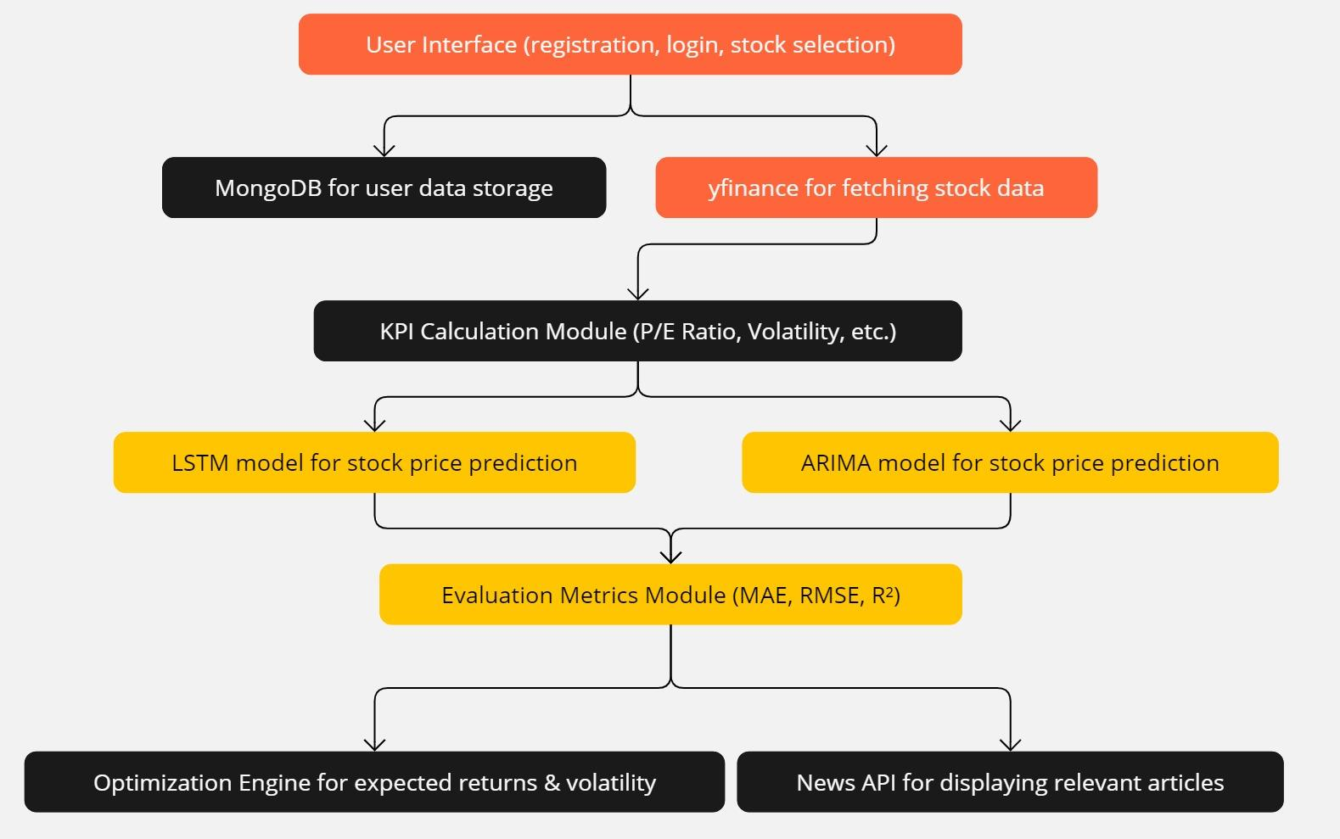

**Fig 4.1.1 Block Diagram**

this block diagram outlines a comprehensive approach to data-driven investment, using classification, analysis, and visualization to create a balanced and informed portfolio.

### 1. User Interface (UI)

The **UI** serves as the front-end where users interact with the system. This is the interface they see and engage with. In this project, the UI is built using **Streamlit**, providing an intuitive and streamlined experience for users to manage their stock portfolios.

* **Registration/Login**: Users create an account, store their credentials, and log in to access personalized data.
* **Stock Selection**: Once logged in, users can select stocks they are interested in tracking or investing in. The interface presents them with real-time data fetched from yFinance and allows easy interaction, with features like search bars and filters to find stocks quickly.

This UI is crucial for ensuring user engagement and ease of use, as it simplifies complex stock market data and financial metrics into a visually appealing and user-friendly format.

### 2. MongoDB for User Data Storage

The **MongoDB database** is used to store critical user information. Since MongoDB is a NoSQL database, it offers flexible and scalable storage for different types of data, such as:

* **Login credentials**: Usernames and passwords are securely stored for authentication purposes.
* **Preferences**: User preferences regarding stocks, risk levels, and portfolio strategies are saved, allowing the app to personalize the user experience.
* **Past Portfolio Details**: Any historical portfolio data, including investment history, profit/loss, and portfolio performance, is stored for easy access and review.

MongoDB helps ensure data consistency, security, and scalability, allowing the system to grow as more users and data are added.

### 3. yFinance for Fetching Stock Data

The **yFinance API** is used to gather real-time stock market data, which is essential for analyzing stock performance and making predictions. This data includes:

* **Historical prices**: Past stock prices over various time periods, which are used to train the machine learning models.
* **Financial metrics**: Indicators such as earnings, dividends, and market cap.
* **Other stock-related information**: Volume, price changes, and stock-specific news.

yFinance provides accurate and up-to-date information, which is crucial for the stock price prediction models to deliver reliable forecasts.

### 4. KPI Calculation Module

This module computes **Key Performance Indicators (KPIs)**, which are essential financial metrics that help users evaluate the performance and risk associated with a stock. Some KPIs calculated include:

* **Price-to-Earnings (P/E) Ratio**: A metric to assess the valuation of a company, helping users understand if a stock is overvalued or undervalued.
* **Volatility**: Measures the price fluctuations of a stock, aiding in risk assessment.
* **Other relevant metrics**: Return on Equity (ROE), Dividend Yield, and Beta (risk relative to the market).

This module empowers users by giving them insights into the health and stability of stocks, facilitating more informed investment decisions.

### 5. LSTM Model for Stock Price Prediction

**Long Short-Term Memory (LSTM)** is a type of recurrent neural network (RNN) that excels at predicting time-series data, such as stock prices. In this project:

* **LSTM** analyzes historical stock price data fetched from yFinance and learns patterns over time.
* It predicts future stock prices by capturing trends and accounting for time dependencies, such as seasonal effects or market cycles.

LSTM is particularly good at handling complex, non-linear relationships in time-series data, making it ideal for stock market predictions.

### 6. ARIMA Model for Stock Price Prediction

**ARIMA (Auto-Regressive Integrated Moving Average)** is another popular model for time series forecasting, especially for data with a linear trend. In this project:

* **ARIMA** focuses on capturing linear patterns in the stock market data.
* It uses past stock prices to predict future prices based on trends, moving averages, and lagged relationships.

While ARIMA excels at linear trends, combining it with LSTM allows the system to offer a comparison between linear and non-linear predictions, giving users a more comprehensive view of the market.

### 7. Evaluation Metrics Module

This module assesses the performance of the LSTM and ARIMA models. The system uses metrics such as:

* **Mean Absolute Error (MAE)**: Measures the average magnitude of the errors in the predictions.
* **Root Mean Squared Error (RMSE)**: Penalizes larger errors more heavily, offering insights into prediction accuracy.
* **R-squared (R²)**: Evaluates how well the predictions match the actual stock prices.

These evaluation metrics help users understand the reliability and precision of the models and provide benchmarks for model improvements.

### 8. Optimization Engine for Expected Returns & Volatility

After predicting future stock prices, the **optimization engine** is used to construct an optimal stock portfolio. It balances two main objectives:

* **Maximizing expected returns**: Based on predicted stock prices, the system suggests a portfolio with the highest potential returns.
* **Minimizing volatility**: The engine also aims to minimize risk by selecting a combination of stocks that smooth out fluctuations in the overall portfolio value.

This optimization is based on financial models like **Modern Portfolio Theory (MPT)**, ensuring the user’s portfolio is balanced between risk and return.

### 9. News API for Displaying Relevant Articles

The integration of a **News API** allows the system to display the latest news articles related to the stocks users are tracking or interested in. This helps users stay up-to-date with events or trends that might impact the market, such as:

* **Company news**: Earnings reports, mergers, or acquisitions.
* **Industry news**: Economic shifts, new regulations, or technological advancements.
* **Global events**: Geopolitical events or crises that could affect the stock market.

By providing relevant news, the system enhances the user’s ability to make well-informed investment decisions based on current events and market sentiment.

**4.2. Modular diagram representation of the proposed system**

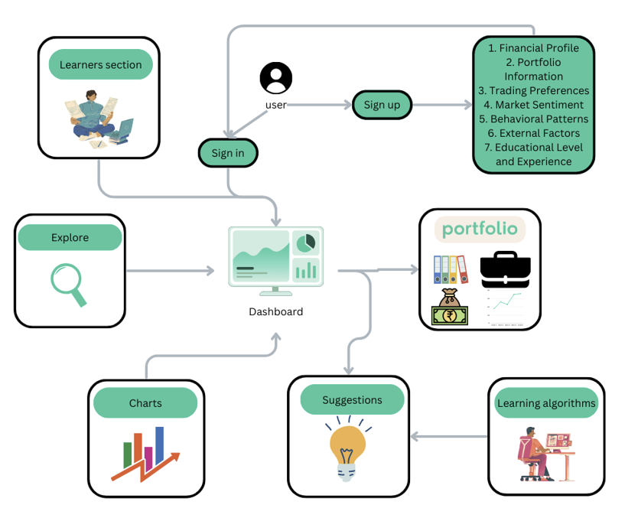

**Fig 4.2.1 Modular Diagram**

* **User Sign Up/Sign In:**

1. Sign Up: New users register by providing detailed information including:
2. Financial Profile: Their income, assets, liabilities, etc.
3. Portfolio Information: Details of existing investments.
4. Trading Preferences: Their investment strategies and risk tolerance.
5. Market Sentiment: Their outlook on market trends.
6. Behavioral Patterns: Their past trading behaviors and habits.
7. External Factors: Influences like economic indicators.
8. Educational Level and Experience: Their financial knowledge and experience.
9. Sign In: Returning users access their accounts.

* **Dashboard:**

The user accesses a central hub that provides an overview of their financial data and portfolio status. This includes summaries of their assets, recent transactions, and alerts for significant portfolio changes.

* **Portfolio:**

The user can delve into detailed information about their investments, including individual asset performance, portfolio diversification, and overall financial health.

* **Suggestions:**

Based on the user's data, the system generates personalized investment suggestions. These suggestions are derived from the analysis performed by the learning algorithms.

* **Learning Algorithms:**

These algorithms continuously analyze the user’s financial data, market trends, and other factors to provide tailored insights and investment recommendations. They learn from the user’s behavior to refine future suggestions.

* **Charts:**

Users can view various charts that visualize their financial data. This could include performance graphs, trend analyses, and comparative charts that make understanding complex financial information easier.

* **Explore:**

This section allows users to search for additional resources, tools, and information that can aid in their financial decision-making. It might include market news, research reports, and financial calculators.

* **Learners Section:**

This educational module provides users with access to financial learning materials. It helps users improve their financial literacy and make informed investment decisions, offering articles, tutorials, and interactive courses.

This modular system provides a comprehensive approach to managing and understanding one’s financial portfolio, blending personalized insights with educational resources to empower users in their investment journeys.

**4.3 Implementation**

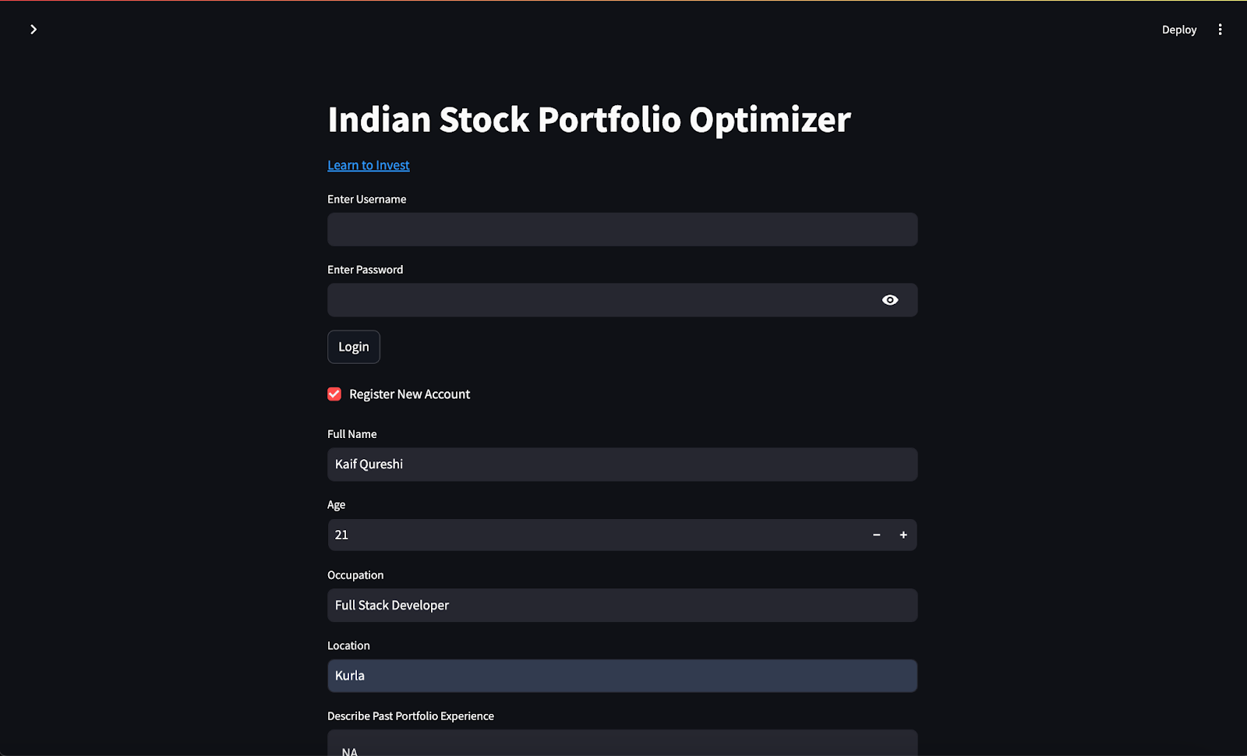

**Fig 4.3.1(a) Registration**

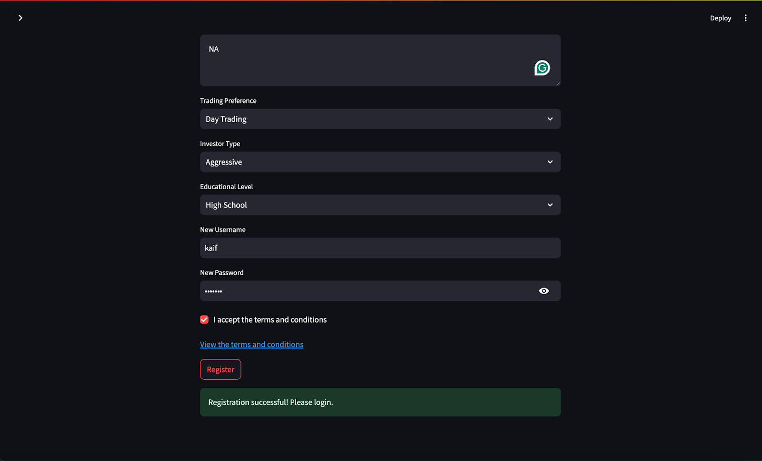

**Fig 4.3.1(b) Registration**

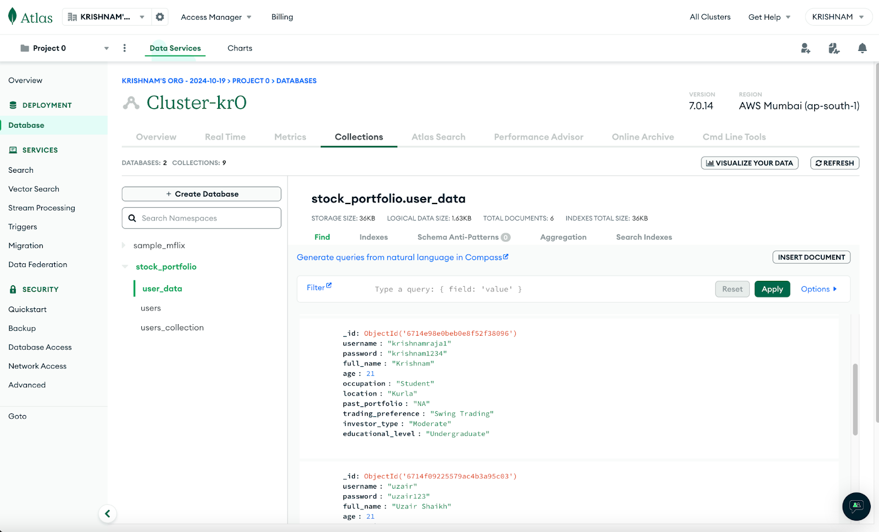

**Fig 4.3.2 MongoDB Database**

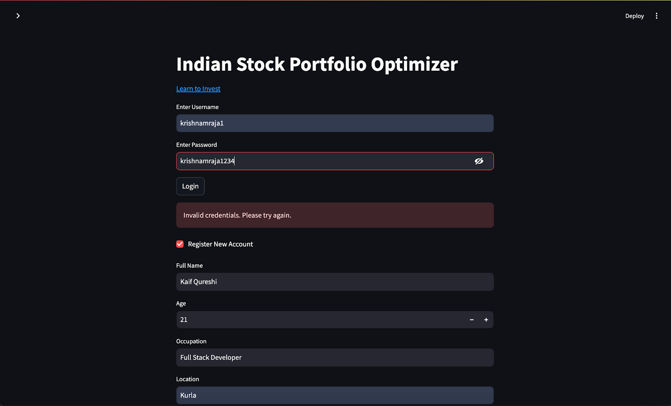

**Fig 4.3.3(a) Invalid user Sign in**

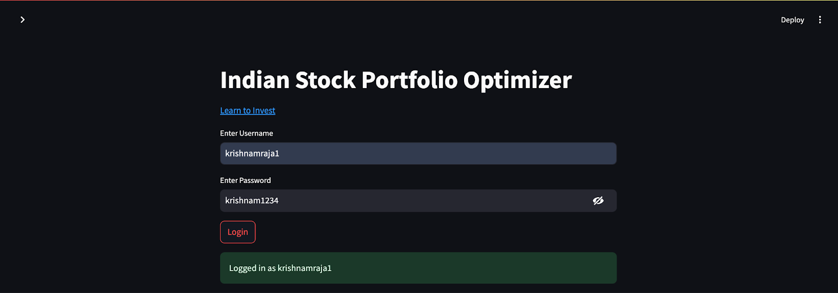

**Fig 4.3.3(b) Valid user Sign in**

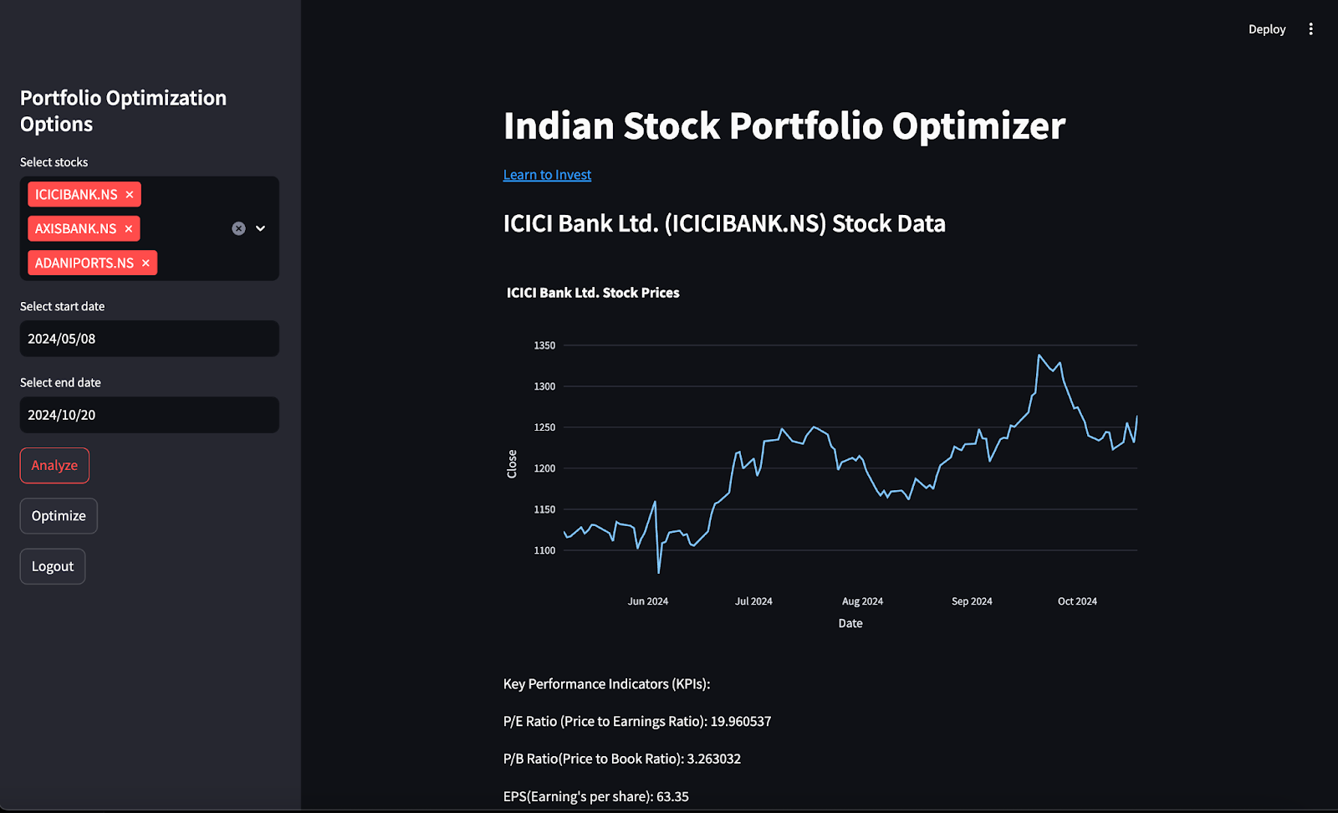

**Fig 4.3.4 User Dashboard**

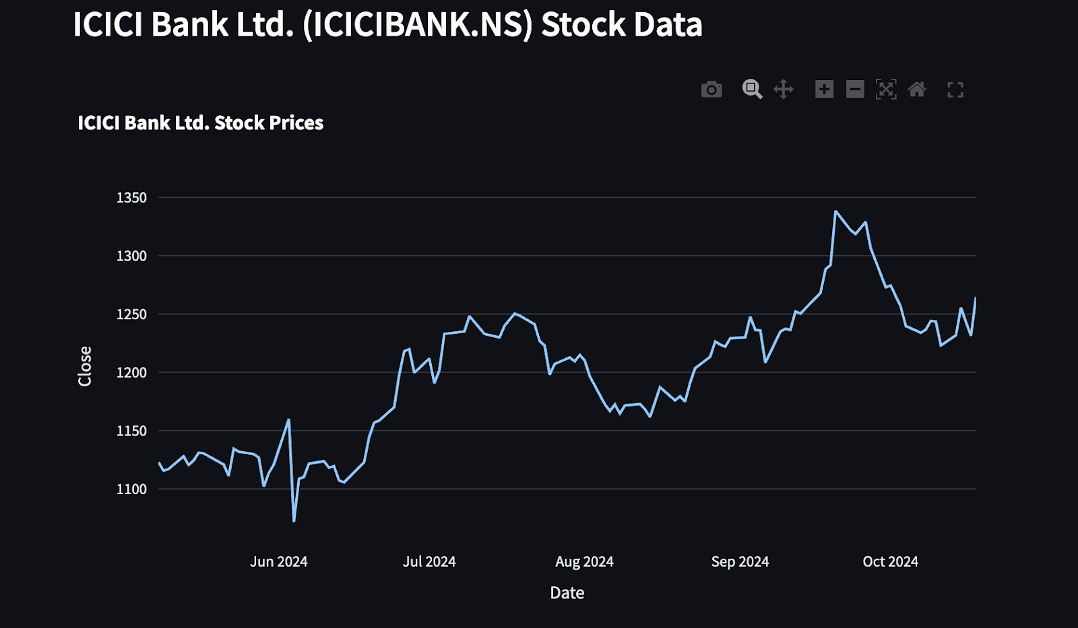

**Fig 4.3.5 Graph of selected stock (ICICI Bank)**

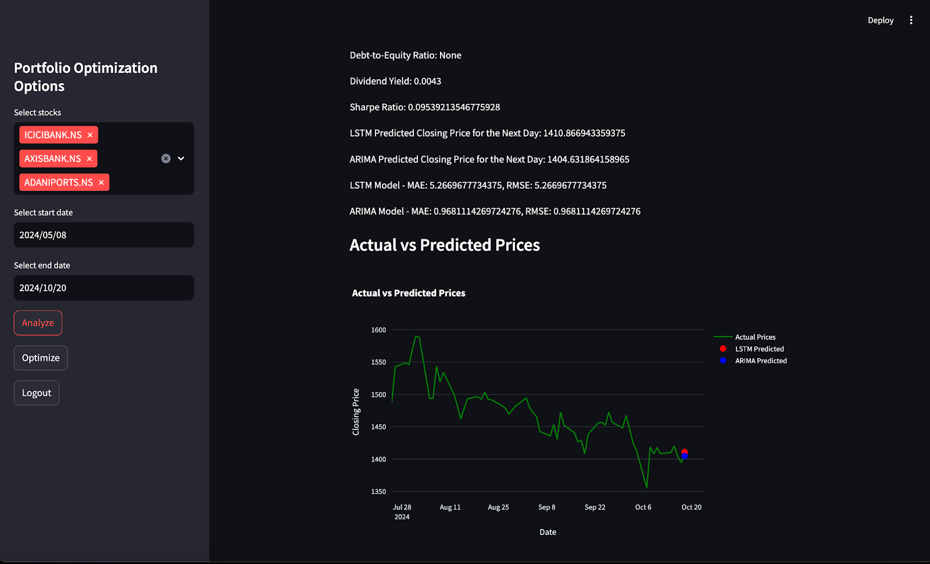

**Fig 4.3.6 Predictions**

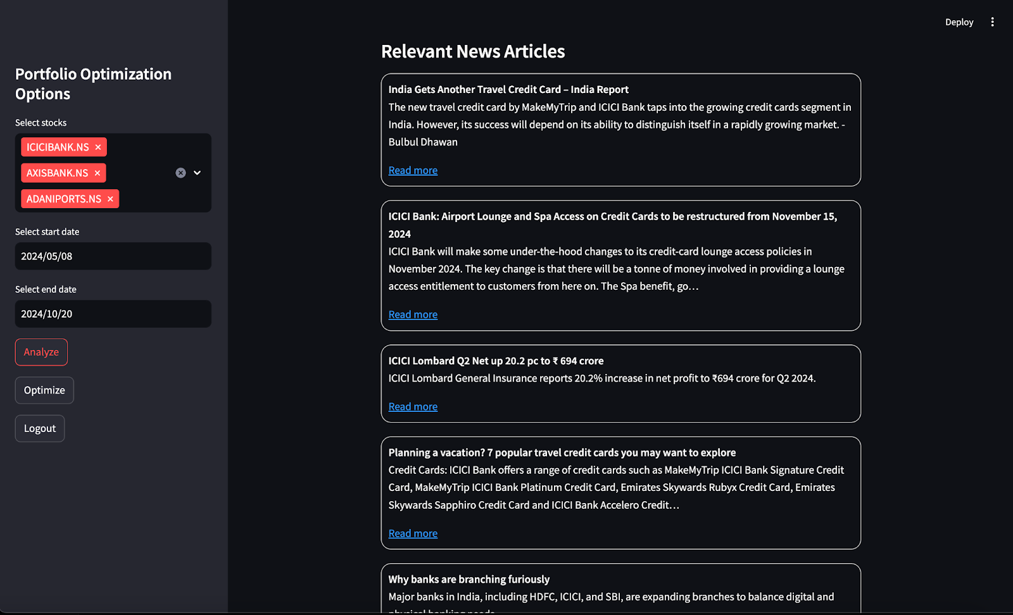

**Fig 4.3.7 Latest news of selected stock**



**Fig 4.3.8 News Article**

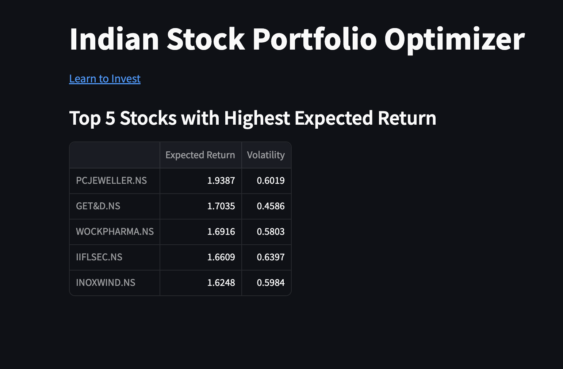

**Fig 4.3.9 Suggestions**

**4.4. Project Scheduling & Tracking using Timeline / Gantt Chart**

#### Phase 1: Literature Review and Requirement Gathering (July 18 – July 31)

* **Tasks:**
  + Conduct background research on portfolio optimization techniques and risk management models.
  + Analyze existing systems and identify gaps.
  + Gather functional and non-functional requirements.
  + Study relevant algorithms (ARIMA, LSTM, BiLSTM) and determine their relevance for portfolio prediction.
  + Explore data sources like yFinance and NewsAPI for real-time financial data and news.
* **Deliverables:**
  + Completed literature review.
  + Well-documented project requirements and scope.

#### Phase 2: App Design and Framework Setup (August 1 – August 14)

* **Tasks:**
  + Design the architecture of the Streamlit application.
  + Set up a MongoDB database for user authentication and data storage.
  + Implement the signup/login functionality.
  + Start integrating yFinance API for stock data retrieval.
  + Implement the news section using NewsAPI.
* **Deliverables:**
  + Basic app framework with authentication and news integration.

#### Phase 3: Core Algorithm Development (August 15 – September 7)

* **Tasks:**
  + Develop and test ARIMA and LSTM models for stock price prediction.
  + Build portfolio optimization models incorporating user risk preferences and constraints.
  + Implement Monte Carlo simulations for risk assessment.
  + Test the performance of models with historical data.
* **Deliverables:**
  + Working stock prediction models (ARIMA, LSTM).
  + Initial portfolio optimization feature using Modern Portfolio Theory (MPT).

#### Phase 4: App Development and Personalization Features (September 8 – September 21)

* **Tasks:**
  + Add personalized recommendations for the user based on their investment profile.
  + Integrate additional investment options like SIPs and mutual funds into the app.
  + Ensure users can search for and analyze SIPs and mutual funds.
  + Fine-tune user interface for better interaction and engagement.
* **Deliverables:**
  + Enhanced user personalization and investment options.

#### Phase 5: Testing and Performance Evaluation (September 22 – October 5)

* **Tasks:**
  + Conduct system testing for bugs and performance issues.
  + Perform sensitivity analysis on stock prediction models.
  + Evaluate accuracy and efficiency of the portfolio optimization and risk management models.
  + Generate graphs (e.g., Accuracy vs. Time, Sensitivity Reports).
* **Deliverables:**
  + Testing report.
  + Graphical representation of model performance.

#### Phase 6: Final Refinements and Report Writing (October 6 – October 21)

* **Tasks:**
  + Refine the app and fix any remaining bugs.
  + Finalize all project documentation, including the report and technical details.
  + Prepare final presentation and project demonstration.
  + Incorporate feedback and adjust app features as necessary.
* **Deliverables:**
  + Final version of the app.
  + Project report and documentation.
  + Project demonstration.

| **Phase** | **Tasks** | **Start Date** | **End Date** |
| --- | --- | --- | --- |
| Phase 1: Literature Review | Research, Requirement Gathering, Algorithm Study | July 18, 2024 | July 31, 2024 |
| Phase 2: App Design | App Architecture, Database Setup, APIs Integration | August 1, 2024 | August 14, 2024 |
| Phase 3: Algorithm Development | Develop ARIMA, LSTM Models, Portfolio Optimization | August 15, 2024 | September 7, 2024 |
| Phase 4: App Development | Personalization Features | September 8, 2024 | September 21, 2024 |
| Phase 5: Testing & Evaluation | System Testing, Sensitivity Analysis, Graphs | September 22, 2024 | October 5, 2024 |
| Phase 6: Final Refinement | Refinements, Documentation, Final Report | October 6, 2024 | October 21, 2024 |

**Table 4.4.1 Schedule**

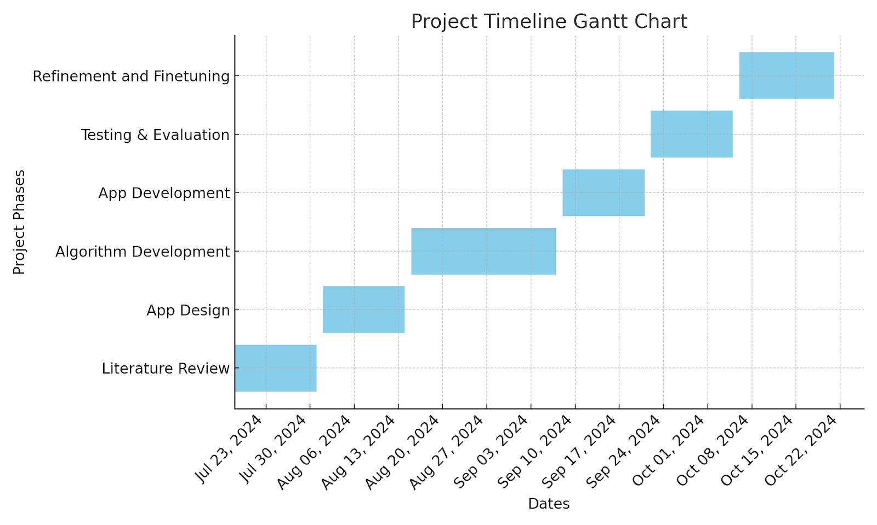

**Fig 4.6.1 Gantt Chart**

### 

### 

### 

### 

### 

### 

### 

### 

### 

### 

### 5. Proposed Results and Discussions

The system is designed to provide comprehensive outputs that facilitate stock portfolio optimization and price prediction using machine learning models. The expected results and evaluation parameters are outlined as follows:

#### 5.1 Determination of Efficiency

The efficiency of the system will be determined through its ability to provide reliable stock price predictions and portfolio recommendations. Key features contributing to efficiency include:

* **Prediction Models**: The system utilizes LSTM and ARIMA models to predict stock prices. These models process historical data to generate accurate forecasts.
* **Expected Return and Volatility**: For portfolio optimization, the system calculates expected returns and volatility, recommending the top 5 stocks based on the highest expected return.

#### 5.2 Determination of Accuracy

The accuracy of the system is measured through various evaluation metrics applied to the prediction models. These include:

* **Mean Absolute Error (MAE)**: Indicates the average absolute difference between the predicted and actual stock prices.
* **Root Mean Squared Error (RMSE)**: Provides a measure of the difference between predicted values and actual values.
* **R² Score**: Reflects how well the prediction model fits the actual data, providing insights into model accuracy.
* **Graphical Representation**: The system generates interactive graphs to visually compare predicted vs actual prices for enhanced clarity.

#### 

#### 

#### 

#### 5.3 Reports on Sensitivity Analysis

The system allows users to analyze stock performance under different market conditions by evaluating various Key Performance Indicators (KPIs) such as:

* **Price-to-Earnings Ratio (P/E)**
* **Dividend Yield**
* **Volatility**
* **Debt-to-Equity Ratio**

These KPIs help users understand the sensitivity of their portfolios to market fluctuations and assess potential risk.

#### 5.4 Graphs of Accuracy vs. Time and Other Metrics

The system visualizes the prediction results with the following graphs:

* **Predicted vs Actual Prices**: This graph compares the predicted stock prices with actual historical data, providing a clear understanding of model performance over time.
* **Model Evaluation Metrics**: Key metrics like MAE, RMSE, and R² are calculated and reported to show the accuracy of the models, ensuring users have clear and reliable performance data.

### 6. Plan of action for the next semester

**a. Work Done Till Date**

So far, we have successfully completed the refinement phase of the project. This includes conducting an in-depth literature review, which helped us gain insights into existing systems and solutions as well as fine tuning. We have also built the foundation of the application, implementing the appropriate algorithms to use for portfolio optimization and risk management. Additionally, we have integrated a news section into the app, allowing users to stay updated on financial news relevant to their portfolios.

### b. Plan of Action for Project II

Moving forward, the second phase of the project will focus on enhancing the functionality and user experience of the app. The following actions will be taken:

1. **Search for SIPs and Mutual Funds**: We plan to expand the app’s functionality by allowing users to search for Systematic Investment Plans (SIPs) and mutual funds, providing them with a broader range of investment options.
2. **Performance Optimization**: We will focus on improving the efficiency and accuracy of the portfolio optimization algorithms.
3. **User Feedback Integration**: We plan to gather user feedback through testing and make iterative improvements based on their input to ensure the app is user-friendly and effective.

This will ensure a robust system that not only helps users optimize their portfolios but also provides a personalized investment experience.

### 7. Conclusion

The project aims to revolutionize the way individuals approach investment strategies. By leveraging sophisticated algorithms and advanced quantitative methods, we are developing a comprehensive system that not only optimizes portfolio performance but also integrates risk management practices.

Throughout the project, we have laid a solid foundation by conducting thorough research and implementing key features that enhance user experience and engagement. The integration of real-time news and personalized recommendations positions the application to be a valuable tool for both retail and professional investors.

As we move into the next phase, our focus will remain on enhancing functionality, ensuring the app adapts to user preferences, and expanding investment options. By continuously iterating based on user feedback and advancements in quantitative finance, we aim to create a robust platform that empowers users to make informed investment decisions.

In summary, this project not only addresses existing gaps in portfolio management tools but also contributes to the broader field of financial technology, fostering more equitable access to sophisticated investment management resources. Through ongoing development and optimization, we anticipate that our system will play a significant role in shaping the future of investment strategies and risk management in the financial industry.

### 8. References

[1] [Marin Lolic, “Practical Improvements to Mean-Variance Optimization for Multi-Asset Class Portfolios”, J. Risk Financial Manag. 2024, 17(5), 183.](https://www.mdpi.com/1911-8074/17/5/183)

[2] [Yu Ma, Rui Mao, Qika Lin, Peng Wu, Erik Cambria, “Quantitative stock portfolio optimization by multi-task learning risk and return”, Information Fusion Volume 104, April 2024, 102165](https://www.sciencedirect.com/science/article/abs/pii/S1566253523004815?via%3Dihub)

[3] [Preeti Paranjape-Voditel, Umesh Deshpande, A stock market portfolio recommender system based on association rule mining, Applied Soft Computing, Volume 13, Issue 2, 2013](https://www.sciencedirect.com/science/article/abs/pii/S1568494612004322?via%3Dihub)

[4] [Jie Zou, Jiashu Lou, Baohua Wang, Sixue Liu, A novel Deep Reinforcement Learning based automated stock trading system using cascaded LSTM networks, Expert Systems with Applications, Volume 242, 2024](https://www.sciencedirect.com/science/article/abs/pii/S0957417423033031?via%3Dihub)

[5] [Zaharaddeen Karami Lawal; Hayati Yassin; Rufai Yusuf Zakari”Stock Market Prediction using Supervised Machine Learning Techniques: An Overview”2020 IEEE Asia-Pacific Conference on Computer Science and Data Engineering (CSDE), 2020](https://sci-hub.se/https://ieeexplore.ieee.org/document/9411609)

[6] [AmirMohammad Larni-Fooeik,Seyed Jafar Sadjadi,Emran Mohammadi , “Stochastic portfolio optimization: A regret-based approach on volatility risk measures: An empirical evidence from The New York stock market”, April 22, 2024](https://journals.plos.org/plosone/article?id=10.1371/journal.pone.0299699)

[7] [David Ajiga, Rhoda adura Adeleye, Tula Sunday Tubokirifuruar, Binaebi Bello, Onyeka, Franca Asuzu, Oluwaseyi Rita Owolabi, ” MACHINE LEARNING FOR STOCK MARKET FORECASTING: A REVIEW OF MODELS AND ACCURACY”, Finance &amp; Accounting Research Journal, Volume 6, Issue 2, February 2024](https://www.researchgate.net/publication/380289212_MACHINE_LEARNING_FOR_STOCK_MARKET_FORECASTING_A_REVIEW_OF_MODELS_AND_ACCURACY)

[8] [Research on Optimization Strategy of Quantitative Investment Scheme Based on Black-Litterman Model Jinhui Zhang* , Lanlan Shi, Wei Xu](https://francis-press.com/uploads/papers/3sFXSwHmglRb1BhSQ5ObXItQuFXhQPairPdApWOQ.pdf)

[9] [N. . Pai, I. . V., and N. . B., “An Optimal Portfolio Construction for Asset Management with Back-Test Using PSO Algorithm and PyPortfolioOpt in Indian Stock Market”, Int J Intell Syst Appl Eng, vol. 12, no. 2s, pp. 352 –, Oct. 2023](https://ijisae.org/index.php/IJISAE/article/view/3634)

[10] [Sen, J., Dasgupta, A., Sengupta, P. P., & Choudhury, S. R. (2023). A Comparative Study of Portfolio Optimization Methods for the Indian Stock Market. ArXiv. /abs/2310.14748](https://arxiv.org/pdf/2310.14748)

### 9. Appendix

**a. List of Figures**

| Figure Number | Heading | Page no. |
| --- | --- | --- |
| 4.1.1 | Block Diagram | 23 |
| 4.2.1 | Modular Diagram | 25 |
| 4.3.1(a) | Registration | 30 |
| 4.3.1(b) | Registration | 31 |
| 4.3.2 | MongoDB Database | 31 |
| 4.3.3(a) | Invalid user Sign in | 32 |
| 4.3.3(b) | Valid user Sign in | 32 |
| 4.3.4 | User Dashboard | 33 |
| 4.3.5 | Graph of selected stock (ICICI Bank) | 33 |
| 4.3.6 | Predictions | 34 |
| 4.3.7 | Latest news of selected stock | 34 |
| 4.3.8 | News Article | 35 |
| 4.3.9 | Suggestions | 35 |
| 4.6.1 | Gantt Chart | 35 |

**b. List of tables**

| Table Number | Heading | Page no. |
| --- | --- | --- |
| 2.1 | Research papers referred | 14, 15, 16 |
| 2.2 | Limitation Existing system or Research gap | 16 |
| 4.6.1 | Gantt Chart | 39 |